Chapter 4, Problem 1.

Calculate the current i_{o} in the circuit of Fig. 4.69. What value of input voltage is necessary to make i_{o} equal to 5 amps?

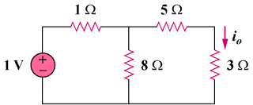
30V
5 Ω
25 Ω
15 Ω
40 Ω

Figure 4.69
For Prob. 4.1.

